SENG383 FINAL

PROJECT REPORT

LINK FOR YOUTUBE VIDEO EXPLAINING KIDTASK AND USING THE APPLICATION

https://youtu.be/tsCgwQxybPo
FOR THE PROJECT “KIDTASK” I HAVE DEVELOPED TWO VERSION BEACUSE I WASN’T SATISFIED ENOUGHT WITH THE FIRST VERSION. AND TRIED TO DEVELOP A
- BETTER USER INTERFACE (UI)
- BETTER FUNCTIONALITIES
- EASY TO READ AND CODE
- NOT MUCH OF CONFIGURATION NEEDED FOR MAVEN
- MORE SIMILAR TO THE DESIGNS AND CHILD-FRIENDLY GUI

VERSION. THIS IS HOW V2 CAME UP. I USED GITHUB AS A VERSION CONTROL TOOL WHICH IS SAID FROM THE BEGINNING OF THE PROJECT. THIS PROJECT HAS GREATLY IMPROVED AND ENCOUREGED ME IN TERMS OF USING GIT.

SENG383 GITHUB REPOSITORY LINK:
https://github.com/esmaesss/SENG383-project

SOURCE CODES FOR KIDTASK AND BEEPLAN IN SENG383 REPOSITORY

- BEEPLAN
from models import Instructor

class ConstraintManager:
DAYS = ["Monday", "Tuesday", "Wednesday", "Thursday", "Friday"]
HOURS = [9, 10, 11, 12, 13, 14, 15, 16]

@staticmethod
def is_exam_block(day: str, hour: int) -> bool:
# Rule: No courses Friday 13:20–15:10
return day == "Friday" and hour in [13, 14]

@staticmethod
def check_instructor_availability(instructor: Instructor, day: str, hour: int, is_lab: bool) -> bool:
# 1. Check if already busy at this specific time
for slot in instructor.assigned_slots:
if slot.day == day and slot.start_hour == hour:
return False

# 2. Check max daily theory load (4 hours)
if not is_lab:
if not instructor.can_teach_theory(day):
return False
return True

@staticmethod
def check_year_overlap(schedule_map, year: int, day: str, hour: int):
# Rule: Only one course per year-group at a time
if (year, day, hour) in schedule_map:
return False
return True

import sys
from PyQt5.QtWidgets import (QMainWindow, QWidget, QVBoxLayout, QHBoxLayout, QSplitter,
QPushButton, QTableWidget, QTableWidgetItem, QLabel, QComboBox,
QMessageBox, QHeaderView, QTextEdit, QGroupBox, QFormLayout,
QStatusBar, QMenuBar, QAction, QFrame)
from PyQt5.QtGui import QColor, QFont, QIcon
from PyQt5.QtCore import Qt
from scheduler import BeeScheduler

class BeePlanApp(QMainWindow):
def __init__(self, courses, instructors):
super().__init__()
self.courses = courses
self.instructors = instructors
self.generated_schedule = {} # Stores raw schedule data

self.setWindowTitle("BeePlan - Department Scheduler")
self.resize(1100, 750)
self.init_ui()

def init_ui(self):
self.setWindowTitle("BeePlan - Department Scheduler")
self.resize(1400, 900)

# Create menu bar
self.create_menu_bar()

# Create status bar
self.status_bar = self.statusBar()
self.status_bar.showMessage("Ready")

# Create central widget with splitter
central_widget = QWidget()
self.setCentralWidget(central_widget)
main_layout = QHBoxLayout(central_widget)

# Create splitter for resizable panels
splitter = QSplitter(Qt.Horizontal)
main_layout.addWidget(splitter)

# Left panel - Schedule controls and info
left_panel = self.create_left_panel()
splitter.addWidget(left_panel)

# Right panel - Timetable
right_panel = self.create_timetable_panel()
splitter.addWidget(right_panel)

# Set splitter proportions
splitter.setSizes([400, 1000])

# Initial render
self.mark_static_zones()
self.update_course_info()

def create_menu_bar(self):
menubar = self.menuBar()

# File menu
file_menu = menubar.addMenu('File')

export_action = QAction('Export Schedule', self)
export_action.triggered.connect(self.export_schedule)
file_menu.addAction(export_action)

file_menu.addSeparator()

exit_action = QAction('Exit', self)
exit_action.triggered.connect(self.close)
file_menu.addAction(exit_action)

# Help menu
help_menu = menubar.addMenu('Help')

about_action = QAction('About', self)
about_action.triggered.connect(self.show_about)
help_menu.addAction(about_action)

def create_left_panel(self):
panel = QWidget()
layout = QVBoxLayout(panel)

# Controls group
controls_group = QGroupBox("Schedule Controls")
controls_layout = QVBoxLayout(controls_group)

# Year filter
year_layout = QHBoxLayout()
year_label = QLabel("Filter by Year:")
year_label.setToolTip("Filter the timetable to show only courses from selected year")
year_layout.addWidget(year_label)
self.year_combo = QComboBox()
self.year_combo.addItems(["All Years", "1", "2", "3", "4"])
self.year_combo.setToolTip("Select year to filter courses")
self.year_combo.currentTextChanged.connect(self.refresh_table)
year_layout.addWidget(self.year_combo)
controls_layout.addLayout(year_layout)

# Generate button
self.btn_generate = QPushButton("🔄 Generate Schedule")
self.btn_generate.setToolTip("Generate a new conflict-free schedule for all courses")
self.btn_generate.setStyleSheet("""
QPushButton {
background-color: #4CAF50;
color: white;
font-weight: bold;
padding: 10px;
border-radius: 5px;
font-size: 12px;
}
QPushButton:hover {
background-color: #45a049;
}
QPushButton:pressed {
background-color: #3d8b40;
}
QPushButton:disabled {
background-color: #cccccc;
}
""")
self.btn_generate.clicked.connect(self.run_generation)
controls_layout.addWidget(self.btn_generate)

layout.addWidget(controls_group)

# Course info group
info_group = QGroupBox("Course Information")
info_group.setToolTip("Overview of all courses in the curriculum")
info_layout = QVBoxLayout(info_group)

self.course_info_text = QTextEdit()
self.course_info_text.setReadOnly(True)
self.course_info_text.setMaximumHeight(200)
self.course_info_text.setToolTip("Detailed information about all courses")
self.course_info_text.setStyleSheet("""
QTextEdit {
background-color: #f8f9fa;
border: 1px solid #dee2e6;
border-radius: 3px;
padding: 5px;
}
""")
info_layout.addWidget(self.course_info_text)

layout.addWidget(info_group)

# Statistics group
stats_group = QGroupBox("Schedule Statistics")
stats_group.setToolTip("Statistics about the generated schedule")
stats_layout = QFormLayout(stats_group)

self.stats_labels = {}
stats = ["Total Courses", "Scheduled Slots", "Conflicts", "Utilization"]
for stat in stats:
label = QLabel("0")
self.stats_labels[stat] = label
stats_layout.addRow(stat + ":", label)

layout.addWidget(stats_group)

layout.addStretch()
return panel

def create_timetable_panel(self):
panel = QWidget()
layout = QVBoxLayout(panel)

# Timetable title
title = QLabel("Weekly Timetable")
title.setFont(QFont("Arial", 14, QFont.Bold))
title.setAlignment(Qt.AlignCenter)
layout.addWidget(title)

# Timetable grid
self.table = QTableWidget()
self.table.setRowCount(8)
self.table.setColumnCount(5)
self.days = ["Monday", "Tuesday", "Wednesday", "Thursday", "Friday"]
self.hours = [9, 10, 11, 12, 13, 14, 15, 16]

self.table.setHorizontalHeaderLabels(self.days)
self.table.setVerticalHeaderLabels([f"{h}:20" for h in self.hours])
self.table.horizontalHeader().setSectionResizeMode(QHeaderView.Stretch)
self.table.verticalHeader().setSectionResizeMode(QHeaderView.Stretch)

# Style the table
self.table.setStyleSheet("""
QTableWidget {
gridline-color: #ddd;
selection-background-color: #e3f2fd;
}
QHeaderView::section {
background-color: #1976d2;
color: white;
padding: 8px;
border: 1px solid #1565c0;
font-weight: bold;
}
""")

# Connect cell click
self.table.cellClicked.connect(self.on_cell_clicked)

layout.addWidget(self.table)
return panel

def update_course_info(self):
info_text = f"Total Courses: {len(self.courses)}\n\n"
for course in self.courses:
info_text += f"• {course.code}: {course.name}\n"
info_text += f" Year: {course.year}, Hours: {course.theory_hours}+{course.lab_hours}\n"
info_text += f" Instructor: {course.instructor.name}\n\n"

self.course_info_text.setText(info_text)

def on_cell_clicked(self, row, col):
hour = self.hours[row]
day = self.days[col]

# Find courses scheduled at this time
scheduled_courses = []
for (year, s_day, s_hour), course_code in self.generated_schedule.items():
if s_day == day and s_hour == hour:
# Find course details
course = next((c for c in self.courses if c.code == course_code), None)
if course:
scheduled_courses.append(f"Y{year}: {course_code} - {course.name} ({course.instructor.name})")

if scheduled_courses:
QMessageBox.information(self, f"Schedule for {day} {hour}:20", "\n".join(scheduled_courses))
else:
QMessageBox.information(self, f"Schedule for {day} {hour}:20", "No courses scheduled")

def show_about(self):
QMessageBox.about(self, "About BeePlan",
"BeePlan - Department Course Scheduler\n\n"
"A tool for generating conflict-free course schedules\n"
"for university departments.\n\n"
"Built with PyQt5 and Python.")

def mark_static_zones(self):
"""Paint the Friday Exam block red."""
exam_rows = [4, 5] # 13:20, 14:20 indices
fri_col = 4
for row in exam_rows:
item = QTableWidgetItem("📚 EXAM BLOCK\n(No classes)")
item.setBackground(QColor(255, 87, 87))
item.setForeground(QColor(255, 255, 255))
item.setTextAlignment(Qt.AlignCenter)
item.setFont(QFont("Arial", 9, QFont.Bold))
item.setFlags(Qt.ItemIsEnabled) # Read only
self.table.setItem(row, fri_col, item)

def run_generation(self):
self.btn_generate.setText("🔄 Generating...")
self.btn_generate.setEnabled(False)
self.status_bar.showMessage("Generating schedule...")
self.repaint() # Force UI update

scheduler = BeeScheduler(self.courses)
result = scheduler.solve()

if result:
self.generated_schedule = result
self.refresh_table()
self.update_statistics()
QMessageBox.information(self, "Success", "Schedule generated successfully without conflicts!")
self.status_bar.showMessage("Schedule generated successfully")
else:
QMessageBox.warning(self, "Failed", "Could not generate a valid schedule with current constraints.")
self.status_bar.showMessage("Schedule generation failed")

self.btn_generate.setText("🔄 Generate Schedule")
self.btn_generate.setEnabled(True)

def update_statistics(self):
if not self.generated_schedule:
for label in self.stats_labels.values():
label.setText("0")
return

total_slots = len(self.generated_schedule)
conflicts = 0 # In a real system, you'd check for conflicts

# Calculate utilization (total possible slots vs used)
total_possible = 5 * 8 * 4 # 5 days, 8 hours, 4 years
utilization = (total_slots / total_possible) * 100

self.stats_labels["Total Courses"].setText(str(len(self.courses)))
self.stats_labels["Scheduled Slots"].setText(str(total_slots))
self.stats_labels["Conflicts"].setText(str(conflicts))
self.stats_labels["Utilization"].setText(".1f")

def refresh_table(self):
self.table.clearContents()
self.mark_static_zones()

filter_year = self.year_combo.currentText()

# Color scheme for different years
year_colors = {
1: QColor(135, 206, 235), # Light blue
2: QColor(144, 238, 144), # Light green
3: QColor(255, 218, 185), # Light orange
4: QColor(221, 160, 221) # Light purple
}

# Iterate through generated schedule
for (year, day, hour), course_code in self.generated_schedule.items():

# Apply Filter
if filter_year != "All Years" and str(year) != filter_year:
continue

# Map to Table Coordinates
try:
row_idx = self.hours.index(hour)
col_idx = self.days.index(day)

current_item = self.table.item(row_idx, col_idx)
course = next((c for c in self.courses if c.code == course_code), None)
course_name = course.name if course else course_code

new_text = f"📖 Y{year}: {course_code}\n{course_name}"
if course:
new_text += f"\n👨‍🏫 {course.instructor.name}"

# Handle cell merging text (if multiple years viewed)
if current_item and "EXAM" not in current_item.text():
existing = current_item.text()
new_text = existing + "\n\n" + new_text
elif current_item and "EXAM" in current_item.text():
continue # Don't overwrite exam block

item = QTableWidgetItem(new_text)
item.setTextAlignment(Qt.AlignCenter)
item.setBackground(year_colors.get(year, QColor(200, 200, 200)))
item.setFont(QFont("Arial", 8))
item.setToolTip(f"Course: {course_code}\nName: {course_name}\nYear: {year}\nInstructor: {course.instructor.name if course else 'Unknown'}\nClick for details")
self.table.setItem(row_idx, col_idx, item)

except ValueError:
pass # Hour or Day not in grid range

def export_schedule(self):
if not self.generated_schedule:
QMessageBox.warning(self, "No Schedule", "Please generate a schedule first.")
return

import json
from PyQt5.QtWidgets import QFileDialog

filename, _ = QFileDialog.getSaveFileName(self, "Save Schedule", "", "JSON Files (*.json)")
if filename:
try:
with open(filename, 'w') as f:
json.dump(self.generated_schedule, f, indent=4)
QMessageBox.information(self, "Success", f"Schedule exported to {filename}")
except Exception as e:
QMessageBox.critical(self, "Error", f"Failed to export: {str(e)}")

import sys
import os
from PyQt5.QtWidgets import QApplication
from gui import BeePlanApp
from utils import load_instructors, load_courses

def main():
app = QApplication(sys.argv)

# 1. Path Setup
base_dir = os.path.dirname(os.path.dirname(os.path.abspath(__file__)))
data_dir = os.path.join(base_dir, 'data', 'raw')

inst_path = os.path.join(data_dir, 'instructers.csv')
curr_path = os.path.join(data_dir, 'curriculum.csv')

# Check if files exist
if not os.path.exists(inst_path) or not os.path.exists(curr_path):
print("Error: CSV files not found in 'data/raw/'. Please create them.")
return

# 2. Load Data
print("Loading BeePlan data...")
instructors = load_instructors(inst_path)
courses = load_courses(curr_path, instructors)

print(f"Loaded {len(courses)} courses.")

# 3. Launch GUI
window = BeePlanApp(courses, instructors)
window.show()

sys.exit(app.exec_())

if __name__ == "__main__":
main()

I HAVE ONLY PASTED contraints.py, gui.py and main.py files otherwise the report would be very long.
The rest of the code is included on the repository.

- KIDTASK:
import java.awt.BorderLayout;
import java.awt.CardLayout;
import java.awt.Color;
import java.awt.Component;
import java.awt.Cursor;
import java.awt.Dimension;
import java.awt.FlowLayout;
import java.awt.Font;
import java.awt.GradientPaint;
import java.awt.Graphics;
import java.awt.Graphics2D;
import java.awt.GridLayout;
import java.awt.Insets;
import java.awt.RenderingHints;
import java.awt.event.MouseAdapter;
import java.awt.event.MouseEvent;
import java.awt.geom.RoundRectangle2D;
import java.io.BufferedReader;
import java.io.File;
import java.io.FileReader;
import java.io.FileWriter;
import java.io.IOException;
import java.io.PrintWriter;
import java.text.SimpleDateFormat;
import java.util.ArrayList;
import java.util.Date;
import java.util.List;

import javax.swing.BorderFactory;
import javax.swing.JButton;
import javax.swing.JComponent;
import javax.swing.JDialog;
import javax.swing.JFrame;
import javax.swing.JLabel;
import javax.swing.JOptionPane;
import javax.swing.JPanel;
import javax.swing.JProgressBar;
import javax.swing.JScrollPane;
import javax.swing.JTable;
import javax.swing.JTextArea;
import javax.swing.JTextField;
import javax.swing.SwingConstants;
import javax.swing.SwingUtilities;
import javax.swing.UIManager;
import javax.swing.border.EmptyBorder;
import javax.swing.table.DefaultTableModel;

// --- 1. DATA MODELS ---
class Task {
String title, description, dueDate, status, creatorRole;
int points;

public Task(String title, String description, String dueDate, int points, String status, String creatorRole) {
this.title = title; this.description = description; this.dueDate = dueDate;
this.points = points; this.status = status; this.creatorRole = creatorRole;
}

public String toFileString() {
return title + "|" + description + "|" + dueDate + "|" + points + "|" + status + "|" + creatorRole;
}
}

class Wish {
String name;
int pointsRequired;
boolean isApproved;

public Wish(String name, int pointsRequired, boolean isApproved) {
this.name = name; this.pointsRequired = pointsRequired; this.isApproved = isApproved;
}

public String toFileString() {
return name + "|" + pointsRequired + "|" + isApproved;
}
}

// --- CUSTOM UI COMPONENTS ---

// Panel with a gradient background
class GradientPanel extends JPanel {
private Color color1, color2;

public GradientPanel(Color color1, Color color2) {
this.color1 = color1;
this.color2 = color2;
setOpaque(false);
}

@Override
protected void paintComponent(Graphics g) {
super.paintComponent(g);
Graphics2D g2d = (Graphics2D) g;
g2d.setRenderingHint(RenderingHints.KEY_RENDERING, RenderingHints.VALUE_RENDER_QUALITY);
int w = getWidth();
int h = getHeight();
GradientPaint gp = new GradientPaint(0, 0, color1, w, h, color2);
g2d.setPaint(gp);
g2d.fillRect(0, 0, w, h);
}
}

// Panel with rounded corners
class RoundedPanel extends JPanel {
private Color backgroundColor;
private int cornerRadius = 20;

public RoundedPanel(Color bgColor) {
this.backgroundColor = bgColor;
setOpaque(false);
}

public RoundedPanel(Color bgColor, int radius) {
this.backgroundColor = bgColor;
this.cornerRadius = radius;
setOpaque(false);
}

@Override
protected void paintComponent(Graphics g) {
super.paintComponent(g);
Graphics2D g2d = (Graphics2D) g;
g2d.setRenderingHint(RenderingHints.KEY_ANTIALIASING, RenderingHints.VALUE_ANTIALIAS_ON);
g2d.setColor(backgroundColor);
g2d.fill(new RoundRectangle2D.Float(0, 0, getWidth(), getHeight(), cornerRadius, cornerRadius));
}
}

// A styled button with gradient and rounded corners
class StyledButton extends JButton {
private Color color1, color2;

public StyledButton(String text, Color c1, Color c2) {
super(text);
this.color1 = c1;
this.color2 = c2;
setContentAreaFilled(false);
setFocusPainted(false);
setBorderPainted(false);
setForeground(Color.WHITE);
setFont(new Font("SansSerif", Font.BOLD, 14));
setCursor(new Cursor(Cursor.HAND_CURSOR));
}

@Override
protected void paintComponent(Graphics g) {
Graphics2D g2d = (Graphics2D) g.create();
g2d.setRenderingHint(RenderingHints.KEY_ANTIALIASING, RenderingHints.VALUE_ANTIALIAS_ON);
int w = getWidth();
int h = getHeight();
GradientPaint gp = new GradientPaint(0, 0, color1, w, 0, color2);
g2d.setPaint(gp);
g2d.fill(new RoundRectangle2D.Float(0, 0, w, h, 15, 15));
g2d.dispose();
super.paintComponent(g);
}
}

// Navigation Menu Item
class NavItem extends JLabel {
private boolean isActive = false;
public NavItem(String text, String iconEmoji) {
super(iconEmoji + " " + text);
setFont(new Font("SansSerif", Font.BOLD, 14));
setForeground(Color.GRAY);
setBorder(new EmptyBorder(10, 15, 10, 15));
setCursor(new Cursor(Cursor.HAND_CURSOR));
}

public void setActive(boolean active) {
this.isActive = active;
setForeground(active ? new Color(255, 105, 180) : Color.GRAY); // Pink for active
}
}

// --- MAIN APPLICATION ---
public class KidTaskApp extends JFrame {
private String userRole = "Child";
private int totalPoints = 0, currentLevel = 1;
private int completedTasks = 0, approvedWishes = 0, dailyStreak = 0;
private String lastLoginDate = "";

private List<Task> tasks = new ArrayList<>();
private List<Wish> wishes = new ArrayList<>();

private JPanel mainContentPanel;
private CardLayout cardLayout;

// Navigation Items
private NavItem navHome, navTasks, navWishes, navProgress;
private JLabel userRoleLabel;

public KidTaskApp() {
setupDataFolder();
loadData();
checkStreak();
try { UIManager.setLookAndFeel(UIManager.getSystemLookAndFeelClassName()); } catch (Exception e) {}
showLogin();
}

private void setupDataFolder() {
File folder = new File("data");
if (!folder.exists()) folder.mkdir();
}

private void checkStreak() {
SimpleDateFormat sdf = new SimpleDateFormat("yyyy-MM-dd");
String today = sdf.format(new Date());
if (!today.equals(lastLoginDate)) {
if (!lastLoginDate.isEmpty()) {
// Simple streak logic: if last login was yesterday, increment. Else reset.
// For a real app, you'd need date arithmetic. Here we just increment for a new day.
dailyStreak++;
} else {
dailyStreak = 1;
}
lastLoginDate = today;
}
}

private void showLogin() {
// Using Turkish as in the screenshots
String[] options = {"Öğrenci", "Ebeveyn", "Öğretmen"};
int choice = JOptionPane.showOptionDialog(null, "KidTask'a Hoş Geldiniz\nLütfen rolünüzü seçin:",
"Giriş Yap", JOptionPane.DEFAULT_OPTION, JOptionPane.PLAIN_MESSAGE, null, options, options[0]);
if (choice == -1) System.exit(0);
userRole = options[choice];
initUI();
}

private void initUI() {
setTitle("KidTask");
setSize(1100, 700);
setDefaultCloseOperation(EXIT_ON_CLOSE);
setLocationRelativeTo(null);

// Main background gradient
GradientPanel backgroundPanel = new GradientPanel(new Color(255, 182, 193), new Color(147, 112, 219));
backgroundPanel.setLayout(new BorderLayout());
setContentPane(backgroundPanel);

// --- HEADER ---
JPanel headerPanel = new JPanel(new BorderLayout());
headerPanel.setOpaque(false);
headerPanel.setBorder(new EmptyBorder(10, 20, 10, 20));

// Logo & Role
JPanel logoPanel = new JPanel(new FlowLayout(FlowLayout.LEFT));
logoPanel.setOpaque(false);
JLabel logoLabel = new JLabel("🐵 KidTask");
logoLabel.setFont(new Font("SansSerif", Font.BOLD, 24));
logoLabel.setForeground(Color.WHITE);
userRoleLabel = new JLabel(userRole);
userRoleLabel.setFont(new Font("SansSerif", Font.PLAIN, 16));
userRoleLabel.setForeground(new Color(240, 240, 240));
logoPanel.add(logoLabel);
logoPanel.add(userRoleLabel);

// Navigation
JPanel navPanel = new JPanel(new FlowLayout(FlowLayout.CENTER, 20, 0));
navPanel.setOpaque(false);
navHome = new NavItem("Ana Sayfa", "🏠");
navTasks = new NavItem("Görevler", "📝");
navWishes = new NavItem("Dilekler", "🎁");
navProgress = new NavItem("İlerleme", "⭐");

navHome.addMouseListener(new MouseAdapter() { public void mouseClicked(MouseEvent e) { showView("HOME"); } });
navTasks.addMouseListener(new MouseAdapter() { public void mouseClicked(MouseEvent e) { showView("TASKS"); } });
navWishes.addMouseListener(new MouseAdapter() { public void mouseClicked(MouseEvent e) { showView("WISHES"); } });
navProgress.addMouseListener(new MouseAdapter() { public void mouseClicked(MouseEvent e) { showView("PROGRESS"); } });

navPanel.add(navHome);
navPanel.add(navTasks);
navPanel.add(navWishes);
navPanel.add(navProgress);

// Logout Button
StyledButton logoutBtn = new StyledButton("Çıkış Yap", new Color(255, 105, 180), new Color(255, 69, 0));
logoutBtn.addActionListener(e -> { saveData(); System.exit(0); });

headerPanel.add(logoPanel, BorderLayout.WEST);
headerPanel.add(navPanel, BorderLayout.CENTER);
headerPanel.add(logoutBtn, BorderLayout.EAST);

backgroundPanel.add(headerPanel, BorderLayout.NORTH);

// --- MAIN CONTENT CONTAINER ---
RoundedPanel contentContainer = new RoundedPanel(Color.WHITE, 30);
contentContainer.setLayout(new BorderLayout());
contentContainer.setBorder(new EmptyBorder(20, 20, 20, 20));

// Use CardLayout for switching views
cardLayout = new CardLayout();
mainContentPanel = new JPanel(cardLayout);
mainContentPanel.setOpaque(false);

mainContentPanel.add(createHomeView(), "HOME");
mainContentPanel.add(createTasksView(), "TASKS");
mainContentPanel.add(createWishesView(), "WISHES");
mainContentPanel.add(createProgressView(), "PROGRESS");

contentContainer.add(mainContentPanel, BorderLayout.CENTER);

// Add padding around the container
JPanel paddingPanel = new JPanel(new BorderLayout());
paddingPanel.setOpaque(false);
paddingPanel.setBorder(new EmptyBorder(20, 40, 40, 40));
paddingPanel.add(contentContainer, BorderLayout.CENTER);

backgroundPanel.add(paddingPanel, BorderLayout.CENTER);

showView("HOME"); // Show home view by default
setVisible(true);
}

private void showView(String viewName) {
cardLayout.show(mainContentPanel, viewName);
navHome.setActive(viewName.equals("HOME"));
navTasks.setActive(viewName.equals("TASKS"));
navWishes.setActive(viewName.equals("WISHES"));
navProgress.setActive(viewName.equals("PROGRESS"));
if (viewName.equals("HOME") || viewName.equals("PROGRESS")) {
// Refresh these views when shown
mainContentPanel.add(createHomeView(), "HOME");
mainContentPanel.add(createProgressView(), "PROGRESS");
}
}

// --- VIEW CREATION METHODS ---

private JPanel createHomeView() {
JPanel homePanel = new JPanel(new BorderLayout(0, 20));
homePanel.setOpaque(false);

// Dashboard Cards
JPanel cardsPanel = new JPanel(new GridLayout(1, 3, 20, 0));
cardsPanel.setOpaque(false);

cardsPanel.add(createDashboardCard("Bugünün Motivasyonu", "🏆", totalPoints + "", "Harika gidiyorsun!", new Color(255, 223, 0), new Color(255, 165, 0)));
cardsPanel.add(createDashboardCard("Seviyem", "🎯", currentLevel + "", "Devam et!", new Color(173, 216, 230), new Color(135, 206, 250)));

long pendingCount = tasks.stream().filter(t -> t.status.equals("Pending")).count();
cardsPanel.add(createDashboardCard("Bekleyen Görevler", "✅", pendingCount + "", "Hadi başlayalım!", new Color(144, 238, 144), new Color(60, 179, 113)));

// Motivation Section
RoundedPanel motivationPanel = new RoundedPanel(new Color(245, 245, 245), 20);
motivationPanel.setLayout(new BorderLayout());
motivationPanel.setBorder(new EmptyBorder(15, 20, 15, 20));

JLabel motivationTitle = new JLabel("🎉 Bugünün Motivasyonu");
motivationTitle.setFont(new Font("SansSerif", Font.BOLD, 16));
motivationTitle.setForeground(new Color(100, 100, 100));

JPanel iconsPanel = new JPanel(new FlowLayout(FlowLayout.CENTER, 40, 10));
iconsPanel.setOpaque(false);
iconsPanel.add(createMotivationIcon("🐵", "Maymun Milo"));
iconsPanel.add(createMotivationIcon("🍕", "Pizza Ödülü"));
iconsPanel.add(createMotivationIcon("🦁", "Aslan Leo"));
iconsPanel.add(createMotivationIcon("🍦", "Dondurma"));
iconsPanel.add(createMotivationIcon("🐼", "Panda Pam"));

motivationPanel.add(motivationTitle, BorderLayout.NORTH);
motivationPanel.add(iconsPanel, BorderLayout.CENTER);

homePanel.add(cardsPanel, BorderLayout.NORTH);
homePanel.add(motivationPanel, BorderLayout.CENTER);

return homePanel;
}

private JPanel createDashboardCard(String title, String icon, String value, String subtitle, Color c1, Color c2) {
GradientPanel card = new GradientPanel(c1, c2);
card.setLayout(new BorderLayout());
card.setBorder(new EmptyBorder(15, 20, 15, 20));

JLabel titleLabel = new JLabel(icon + " " + title);
titleLabel.setFont(new Font("SansSerif", Font.BOLD, 16));
titleLabel.setForeground(Color.WHITE);

JLabel valueLabel = new JLabel(value);
valueLabel.setFont(new Font("SansSerif", Font.BOLD, 36));
valueLabel.setForeground(Color.WHITE);

JLabel subtitleLabel = new JLabel(subtitle);
subtitleLabel.setFont(new Font("SansSerif", Font.PLAIN, 14));
subtitleLabel.setForeground(new Color(240, 240, 240));

card.add(titleLabel, BorderLayout.NORTH);
card.add(valueLabel, BorderLayout.CENTER);
card.add(subtitleLabel, BorderLayout.SOUTH);

return card;
}

private JPanel createMotivationIcon(String icon, String text) {
JPanel panel = new JPanel(new BorderLayout());
panel.setOpaque(false);
JLabel iconLabel = new JLabel(icon, SwingConstants.CENTER);
iconLabel.setFont(new Font("SansSerif", Font.PLAIN, 40));
JLabel textLabel = new JLabel(text, SwingConstants.CENTER);
textLabel.setFont(new Font("SansSerif", Font.PLAIN, 12));
textLabel.setForeground(Color.GRAY);
panel.add(iconLabel, BorderLayout.CENTER);
panel.add(textLabel, BorderLayout.SOUTH);
return panel;
}

private JPanel createTasksView() {
JPanel tasksPanel = new JPanel(new BorderLayout(0, 20));
tasksPanel.setOpaque(false);

// Header with "Add Task" button
JPanel header = new JPanel(new BorderLayout());
header.setOpaque(false);
JLabel title = new JLabel("📝 Görevlerim");
title.setFont(new Font("SansSerif", Font.BOLD, 24));
title.setForeground(new Color(100, 100, 100));

StyledButton addTaskBtn = new StyledButton("+ Yeni Görev Ekle", new Color(50, 205, 50), new Color(34, 139, 34));
addTaskBtn.addActionListener(e -> showAddTaskDialog());

header.add(title, BorderLayout.WEST);
if (!userRole.equals("Öğrenci")) {
header.add(addTaskBtn, BorderLayout.EAST);
}

// Task List or Empty State
JPanel content = new JPanel(new BorderLayout());
content.setOpaque(false);

if (tasks.isEmpty()) {
JLabel emptyLabel = new JLabel("Henüz görev yok. Hadi bir tane ekleyelim! 🚀", SwingConstants.CENTER);
emptyLabel.setFont(new Font("SansSerif", Font.PLAIN, 16));
emptyLabel.setForeground(Color.GRAY);
content.add(emptyLabel, BorderLayout.CENTER);
} else {
String[] columns = {"Görev", "Bitiş Tarihi", "Puan", "Durum", "Atayan"};
DefaultTableModel model = new DefaultTableModel(columns, 0);
for (Task t : tasks) {
String statusDisplay = t.status.equals("Pending") ? "Bekliyor" : (t.status.equals("Completed") ? "Tamamlandı (Onay Bekliyor)" : "Onaylandı");
model.addRow(new Object[]{t.title, t.dueDate, t.points, statusDisplay, t.creatorRole});
}
JTable table = new JTable(model);
table.setRowHeight(30);
table.setFont(new Font("SansSerif", Font.PLAIN, 14));
table.getTableHeader().setFont(new Font("SansSerif", Font.BOLD, 14));
content.add(new JScrollPane(table), BorderLayout.CENTER);

// Action Button
StyledButton actionBtn = new StyledButton(userRole.equals("Öğrenci") ? "Görevi Tamamla" : "Seçileni Onayla", new Color(100, 149, 237), new Color(65, 105, 225));
actionBtn.addActionListener(e -> {
int row = table.getSelectedRow();
if (row != -1) handleTaskAction(row);
});
JPanel btnPanel = new JPanel(new FlowLayout(FlowLayout.RIGHT));
btnPanel.setOpaque(false);
btnPanel.setBorder(new EmptyBorder(10,0,0,0));
btnPanel.add(actionBtn);
content.add(btnPanel, BorderLayout.SOUTH);
}

tasksPanel.add(header, BorderLayout.NORTH);
tasksPanel.add(content, BorderLayout.CENTER);
return tasksPanel;
}

// Custom Dialog for Adding Task
private void showAddTaskDialog() {
JDialog dialog = new JDialog(this, "Yeni Görev Ekle 🎯", true);
dialog.setSize(500, 450);
dialog.setLocationRelativeTo(this);

RoundedPanel panel = new RoundedPanel(Color.WHITE);
panel.setLayout(new BorderLayout());
panel.setBorder(new EmptyBorder(20, 20, 20, 20));

JPanel formPanel = new JPanel(new GridLayout(4, 1, 10, 15));
formPanel.setOpaque(false);

JTextField titleField = createStyledTextField("Görev Başlığı");
JTextArea descArea = createStyledTextArea("Açıklama");
JTextField dateField = createStyledTextField("Bitiş Tarihi (gg.aa.yyyy)");
JTextField pointsField = createStyledTextField("Puan");
pointsField.setText("10"); // Default value

formPanel.add(createFormField("Görev Başlığı", titleField));
formPanel.add(createFormField("Açıklama", new JScrollPane(descArea)));

JPanel bottomFields = new JPanel(new GridLayout(1, 2, 20, 0));
bottomFields.setOpaque(false);
bottomFields.add(createFormField("Bitiş Tarihi", dateField));
bottomFields.add(createFormField("Puan", pointsField));
formPanel.add(bottomFields);

JPanel buttonPanel = new JPanel(new FlowLayout(FlowLayout.CENTER, 20, 0));
buttonPanel.setOpaque(false);
buttonPanel.setBorder(new EmptyBorder(20, 0, 0, 0));

StyledButton addBtn = new StyledButton("Ekle", new Color(255, 105, 180), new Color(255, 20, 147));
StyledButton cancelBtn = new StyledButton("İptal", Color.LIGHT_GRAY, Color.GRAY);

addBtn.addActionListener(e -> {
try {
tasks.add(new Task(titleField.getText(), descArea.getText(), dateField.getText(), Integer.parseInt(pointsField.getText()), "Pending", userRole));
dialog.dispose();
mainContentPanel.add(createTasksView(), "TASKS"); // Refresh view
cardLayout.show(mainContentPanel, "TASKS");
} catch (NumberFormatException ex) {
JOptionPane.showMessageDialog(dialog, "Lütfen puan için geçerli bir sayı girin.");
}
});
cancelBtn.addActionListener(e -> dialog.dispose());

buttonPanel.add(addBtn);
buttonPanel.add(cancelBtn);

panel.add(formPanel, BorderLayout.CENTER);
panel.add(buttonPanel, BorderLayout.SOUTH);

dialog.setContentPane(panel);
dialog.setVisible(true);
}

private JPanel createFormField(String labelText, JComponent field) {
JPanel panel = new JPanel(new BorderLayout(0, 5));
panel.setOpaque(false);
JLabel label = new JLabel(labelText);
label.setFont(new Font("SansSerif", Font.BOLD, 12));
label.setForeground(Color.GRAY);
panel.add(label, BorderLayout.NORTH);
panel.add(field, BorderLayout.CENTER);
return panel;
}

private JTextField createStyledTextField(String placeholder) {
JTextField field = new JTextField();
field.setFont(new Font("SansSerif", Font.PLAIN, 14));
field.setBorder(BorderFactory.createCompoundBorder(
new RoundedBorder(10), new EmptyBorder(5, 10, 5, 10)));
return field;
}

private JTextArea createStyledTextArea(String placeholder) {
JTextArea area = new JTextArea();
area.setFont(new Font("SansSerif", Font.PLAIN, 14));
area.setRows(3);
area.setLineWrap(true);
area.setBorder(new EmptyBorder(5, 10, 5, 10));
return area;
}

// Simple Rounded Border
private static class RoundedBorder implements javax.swing.border.Border {
private int radius;
RoundedBorder(int radius) { this.radius = radius; }
public Insets getBorderInsets(Component c) { return new Insets(this.radius+1, this.radius+1, this.radius+2, this.radius); }
public boolean isBorderOpaque() { return true; }
public void paintBorder(Component c, Graphics g, int x, int y, int width, int height) {
g.drawRoundRect(x, y, width-1, height-1, radius, radius);
}
}

private JPanel createWishesView() {
JPanel wishesPanel = new JPanel(new BorderLayout(0, 20));
wishesPanel.setOpaque(false);

// Header
JLabel title = new JLabel("🎁 Dileklerim");
title.setFont(new Font("SansSerif", Font.BOLD, 24));
title.setForeground(new Color(100, 100, 100));
wishesPanel.add(title, BorderLayout.NORTH);

// Content or Empty State
JPanel content = new JPanel(new BorderLayout());
content.setOpaque(false);

if (wishes.isEmpty()) {
JLabel emptyLabel = new JLabel("Henüz dilek yok. Hayal et ve ekle! 🌈", SwingConstants.CENTER);
emptyLabel.setFont(new Font("SansSerif", Font.PLAIN, 16));
emptyLabel.setForeground(Color.GRAY);
content.add(emptyLabel, BorderLayout.CENTER);
} else {
String[] columns = {"Dilek", "Gerekli Puan", "Durum"};
DefaultTableModel model = new DefaultTableModel(columns, 0);
for (Wish w : wishes) {
if (w.pointsRequired <= (currentLevel * 100) + 100) {
model.addRow(new Object[]{w.name, w.pointsRequired, w.isApproved ? "Onaylandı" : "Bekliyor"});
}
}
JTable table = new JTable(model);
table.setRowHeight(30);
table.setFont(new Font("SansSerif", Font.PLAIN, 14));
table.getTableHeader().setFont(new Font("SansSerif", Font.BOLD, 14));
content.add(new JScrollPane(table), BorderLayout.CENTER);
}

// Add Wish Button for Child
if (userRole.equals("Öğrenci")) {
StyledButton addWishBtn = new StyledButton("+ Yeni Dilek Ekle", new Color(255, 105, 180), new Color(255, 20, 147));
addWishBtn.addActionListener(e -> handleAddWish());
JPanel btnPanel = new JPanel(new FlowLayout(FlowLayout.RIGHT));
btnPanel.setOpaque(false);
btnPanel.setBorder(new EmptyBorder(10,0,0,0));
btnPanel.add(addWishBtn);
content.add(btnPanel, BorderLayout.SOUTH);
}

wishesPanel.add(content, BorderLayout.CENTER);
return wishesPanel;
}

private JPanel createProgressView() {
JPanel progressPanel = new JPanel(new BorderLayout(0, 20));
progressPanel.setOpaque(false);

// Header
JLabel title = new JLabel("⭐ İlerleme Durumum");
title.setFont(new Font("SansSerif", Font.BOLD, 24));
title.setForeground(new Color(100, 100, 100));
progressPanel.add(title, BorderLayout.NORTH);

JPanel content = new JPanel(new GridLayout(3, 1, 0, 20));
content.setOpaque(false);

// Level Progress Section
JPanel levelPanel = new JPanel(new BorderLayout(0, 10));
levelPanel.setOpaque(false);
JLabel levelTitle = new JLabel("Seviye İlerleme");
levelTitle.setFont(new Font("SansSerif", Font.BOLD, 16));
levelTitle.setForeground(Color.GRAY);

JProgressBar bar = new JProgressBar(0, 100);
bar.setValue(totalPoints % 100);
bar.setStringPainted(true);
bar.setForeground(new Color(255, 105, 180));
bar.setBackground(new Color(230, 230, 250));
bar.setPreferredSize(new Dimension(100, 30));

JPanel labels = new JPanel(new BorderLayout());
labels.setOpaque(false);
labels.add(new JLabel("Seviye " + currentLevel), BorderLayout.WEST);
labels.add(new JLabel(totalPoints + " Puan"), BorderLayout.EAST);

levelPanel.add(levelTitle, BorderLayout.NORTH);
levelPanel.add(bar, BorderLayout.CENTER);
levelPanel.add(labels, BorderLayout.SOUTH);
content.add(levelPanel);

// Achievements Section
JPanel achievementsPanel = new JPanel(new BorderLayout(0, 10));
achievementsPanel.setOpaque(false);
JLabel achTitle = new JLabel("Başarılarım 🏆");
achTitle.setFont(new Font("SansSerif", Font.BOLD, 16));
achTitle.setForeground(Color.GRAY);

JPanel achCards = new JPanel(new GridLayout(1, 4, 10, 0));
achCards.setOpaque(false);
achCards.add(createAchievementCard("İlk Görev", "🌟", new Color(255, 250, 205)));
achCards.add(createAchievementCard("10 Görev", "🏆", new Color(240, 255, 240)));
achCards.add(createAchievementCard("Seviye 5", "💎", new Color(255, 240, 245)));
achCards.add(createAchievementCard("Süper Yıldız", "👑", new Color(230, 230, 250)));

achievementsPanel.add(achTitle, BorderLayout.NORTH);
achievementsPanel.add(achCards, BorderLayout.CENTER);
content.add(achievementsPanel);

// Fun Stats Section
JPanel statsPanel = new JPanel(new BorderLayout(0, 10));
statsPanel.setOpaque(false);
JLabel statsTitle = new JLabel("Eğlenceli İstatistikler 📊");
statsTitle.setFont(new Font("SansSerif", Font.BOLD, 16));
statsTitle.setForeground(Color.GRAY);

JPanel statCards = new JPanel(new GridLayout(1, 3, 10, 0));
statCards.setOpaque(false);
statCards.add(createStatCard("Tamamlanan Görev", "✅", completedTasks + "", new Color(173, 216, 230)));
statCards.add(createStatCard("Onaylanan Dilek", "🎁", approvedWishes + "", new Color(152, 251, 152)));
statCards.add(createStatCard("Günlük Seri", "🔥", dailyStreak + "", new Color(255, 218, 185)));

statsPanel.add(statsTitle, BorderLayout.NORTH);
statsPanel.add(statCards, BorderLayout.CENTER);
content.add(statsPanel);

progressPanel.add(content, BorderLayout.CENTER);
return progressPanel;
}

private JPanel createAchievementCard(String title, String icon, Color bgColor) {
RoundedPanel card = new RoundedPanel(bgColor, 15);
card.setLayout(new BorderLayout());
card.setBorder(new EmptyBorder(15, 10, 15, 10));
JLabel iconLabel = new JLabel(icon, SwingConstants.CENTER);
iconLabel.setFont(new Font("SansSerif", Font.PLAIN, 30));
JLabel titleLabel = new JLabel(title, SwingConstants.CENTER);
titleLabel.setFont(new Font("SansSerif", Font.PLAIN, 12));
titleLabel.setForeground(Color.GRAY);
card.add(iconLabel, BorderLayout.CENTER);
card.add(titleLabel, BorderLayout.SOUTH);
return card;
}

private JPanel createStatCard(String title, String icon, String value, Color bgColor) {
RoundedPanel card = new RoundedPanel(bgColor, 15);
card.setLayout(new BorderLayout());
card.setBorder(new EmptyBorder(15, 15, 15, 15));

JLabel iconLabel = new JLabel(icon);
iconLabel.setFont(new Font("SansSerif", Font.PLAIN, 24));

JLabel valueLabel = new JLabel(value);
valueLabel.setFont(new Font("SansSerif", Font.BOLD, 24));
valueLabel.setForeground(Color.DARK_GRAY);

JLabel titleLabel = new JLabel(title);
titleLabel.setFont(new Font("SansSerif", Font.PLAIN, 12));
titleLabel.setForeground(Color.GRAY);

JPanel top = new JPanel(new BorderLayout());
top.setOpaque(false);
top.add(iconLabel, BorderLayout.WEST);

card.add(top, BorderLayout.NORTH);
card.add(valueLabel, BorderLayout.CENTER);
card.add(titleLabel, BorderLayout.SOUTH);
return card;
}

// --- LOGIC METHODS ---

private void handleAddWish() {
try {
String n = JOptionPane.showInputDialog(this, "Dileğinin adı ne?", "Yeni Dilek", JOptionPane.QUESTION_MESSAGE);
String p = JOptionPane.showInputDialog(this, "Kaç puan değerinde?", "Yeni Dilek", JOptionPane.QUESTION_MESSAGE);
if (n != null && p != null) {
wishes.add(new Wish(n, Integer.parseInt(p), false));
mainContentPanel.add(createWishesView(), "WISHES"); // Refresh view
cardLayout.show(mainContentPanel, "WISHES");
}
} catch (NumberFormatException e) {
JOptionPane.showMessageDialog(this, "Lütfen geçerli bir puan girin.");
}
}

private void handleTaskAction(int row) {
Task t = tasks.get(row);
if (userRole.equals("Öğrenci")) {
if (t.status.equals("Pending")) {
t.status = "Completed";
JOptionPane.showMessageDialog(this, "Harika! Görev tamamlandı, onay bekliyor.");
}
} else {
if (t.status.equals("Completed")) {
t.status = "Approved";
totalPoints += t.points;
currentLevel = (totalPoints / 100) + 1;
completedTasks++; // Increment stat
JOptionPane.showMessageDialog(this, "Görev onaylandı! " + t.points + " puan eklendi.");
}
}
// Refresh views to show updated data
mainContentPanel.add(createTasksView(), "TASKS");
cardLayout.show(mainContentPanel, "TASKS");
}

private void saveData() {
try {
PrintWriter tOut = new PrintWriter(new FileWriter("data/tasks.txt"));
for (Task t : tasks) tOut.println(t.toFileString());
tOut.close();

PrintWriter wOut = new PrintWriter(new FileWriter("data/wishes.txt"));
// Save new stats: points|level|completedTasks|approvedWishes|dailyStreak|lastLoginDate
wOut.println("DATA|" + totalPoints + "|" + currentLevel + "|" + completedTasks + "|" + approvedWishes + "|" + dailyStreak + "|" + lastLoginDate);
for (Wish w : wishes) wOut.println(w.toFileString());
wOut.close();
} catch (IOException e) {
e.printStackTrace();
}
}

private void loadData() {
try (BufferedReader br = new BufferedReader(new FileReader("data/tasks.txt"))) {
String l; while ((l = br.readLine()) != null) {
String[] p = l.split("\\|");
tasks.add(new Task(p[0], p[1], p[2], Integer.parseInt(p[3]), p[4], p[5]));
}
} catch (Exception e) {}

try (BufferedReader br = new BufferedReader(new FileReader("data/wishes.txt"))) {
String l; while ((l = br.readLine()) != null) {
String[] p = l.split("\\|");
if (p[0].equals("DATA")) {
totalPoints = Integer.parseInt(p[1]);
currentLevel = Integer.parseInt(p[2]);
// Load new stats if available
if (p.length > 3) completedTasks = Integer.parseInt(p[3]);
if (p.length > 4) approvedWishes = Integer.parseInt(p[4]);
if (p.length > 5) dailyStreak = Integer.parseInt(p[5]);
if (p.length > 6) lastLoginDate = p[6];
} else {
wishes.add(new Wish(p[0], Integer.parseInt(p[1]), Boolean.parseBoolean(p[2])));
}
}
} catch (Exception e) {}
}

public static void main(String[] args) {
SwingUtilities.invokeLater(KidTaskApp::new);
}
}

Geliştirici (Student A): Esma Çalış - Öğrenci No: 202328017 (AI Tool: Gemini)
Geliştirici (Student B): Esma Çalış - Öğrenci No: 202328017 (AI Tool: ChatGPT)

Diagrams For BeePlan

USE CASE DIAGRAM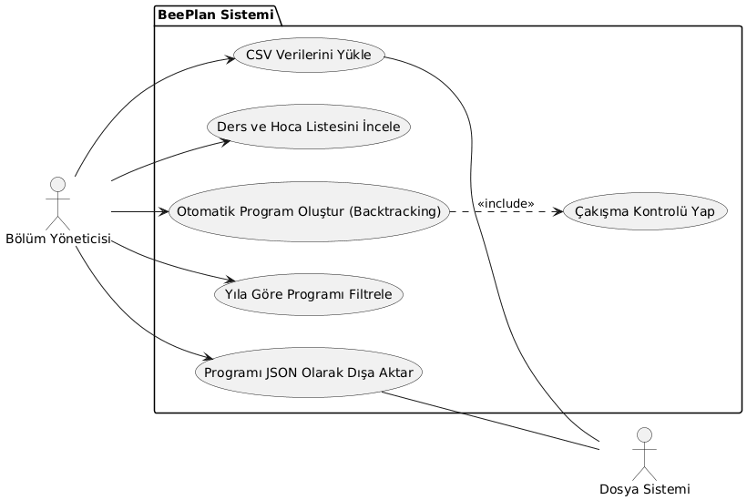

DATA MOODEL DIAGRAM
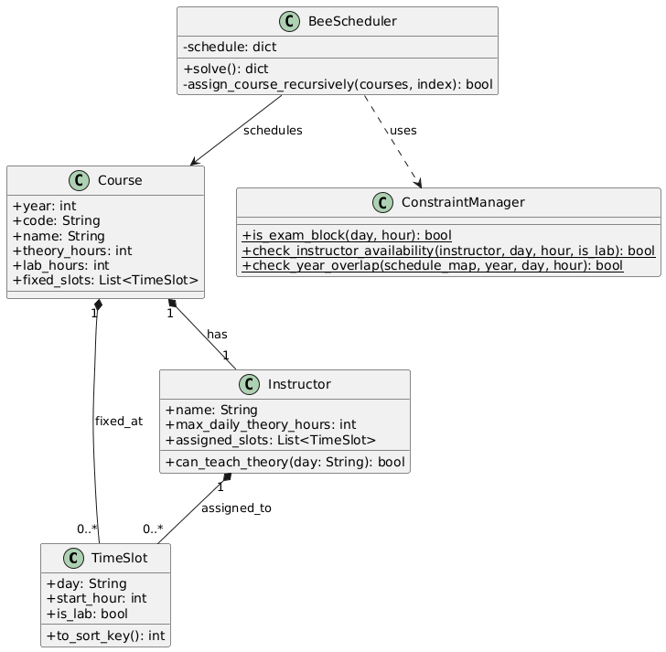

ACTIVITY DIAGRAMS
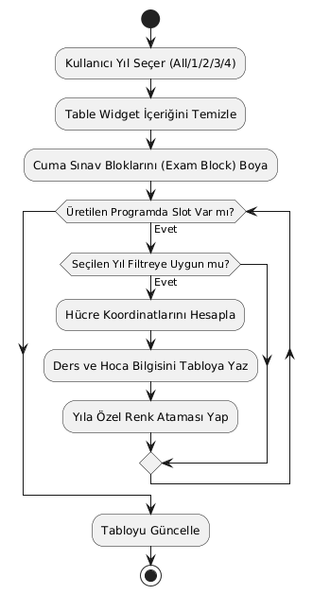
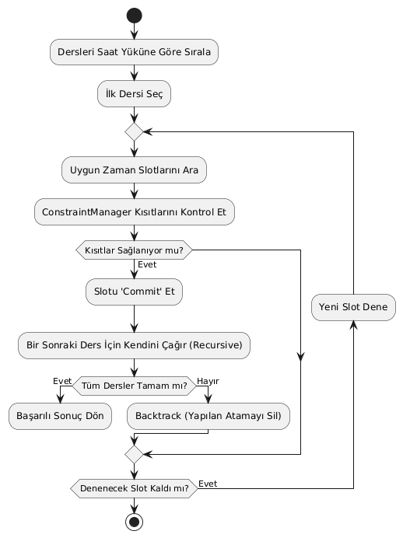
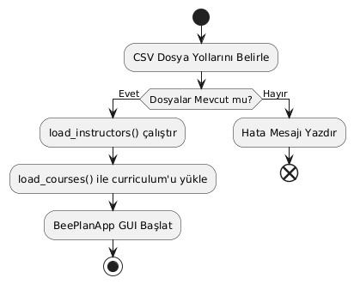

KidTask Diyagramları:
USE CASE DIAGRAM: 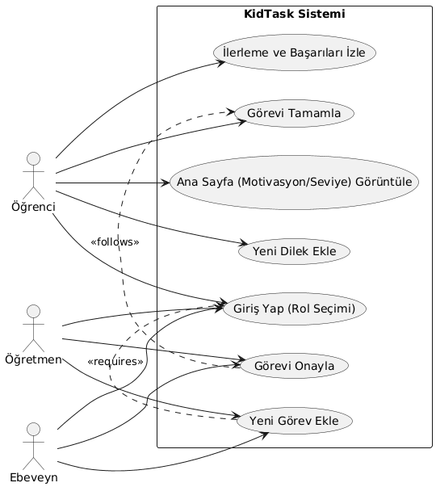

DATA MODEL DIAGRAM:
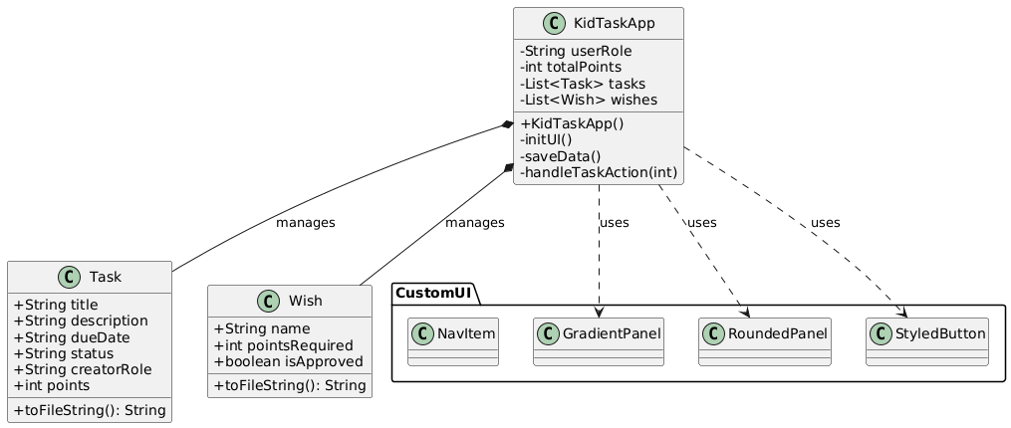

ACTIVITY DIAGRAM TASKACTION:

ACTIVITY DIAGRAM LOADDATA:
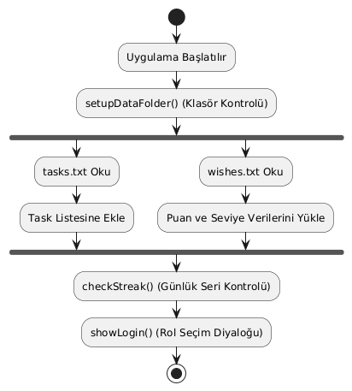

ACTIVITY DIAGRAM showAddTaskDialague
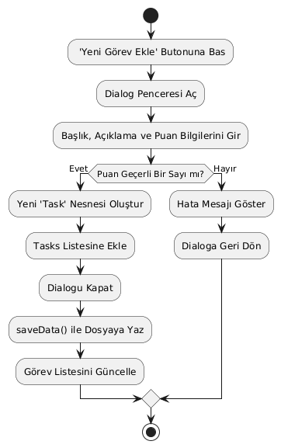

KidTask Projesi (Java Swing)
Bu projede tasarım ve temel yapı için ağırlıklı olarak Gemini ve ChatGPT'den faydalanılmıştır.
Süreç | Kullanılan Araç | Prompt (Komut) | AI Çıktı Analizi | İnsan Müdahalesi (Revision)
Görsel Tasarım (UI) | Gemini | "Java Swing kullanarak Graphics2D ile yuvarlatılmış köşeli (rounded) bir panel ve buton sınıfı oluştur." | AI, paintComponent metodunu doğru sağladı ancak kenarlar tırtıklı görünüyordu². | RenderingHints.KEY_ANTIALIASING eklenerek kenar yumuşatma manuel olarak sağlandı.
Ekran Yönetimi | ChatGPT | "KidTask için CardLayout kullanarak Giriş, Görevler ve Dilekler ekranları arasında geçiş yap." | Kodun iskeleti doğruydu ancak buton tıklamaları ekranları değiştirmiyordu³. | addActionListener blokları ve showView fonksiyonu manuel olarak entegre edildi.
Veri Kalıcılığı | ChatGPT | "Java'da bir listeyi tasks.txt dosyasına pipe (|) karakteriyle ayıran bir kaydetme fonksiyonu yaz." | Fonksiyon dosyaya yazıyordu ancak Türkçe karakterlerde (UTF-8) sorun çıkarıyordu. | BufferedWriter kullanılırken karakter kodlaması ayarı manuel olarak eklendi.

BeePlan Projesi (Python PyQt5)
Bu projede algoritma mantığı ve filtreleme işlemleri için AI araçları rehberlik etmiştir.
Süreç | Kullanılan Araç | Prompt (Komut) | AI Çıktı Analizi | İnsan Müdahalesi (Revision)
GUI Tasarımı | Gemini | "PyQt5 kullanarak solda kontrol paneli, sağda QTableWidget olan bir ders programı arayüzü yaz." | Layout yapısı (Splitter) başarılıydı ancak renkler çok mattı. | QSS (StyleSheet) kodları ile tablo başlıkları ve sınav blokları renklendirildi.
Algoritma Geliştirme | ChatGPT | "Ders programı çakışmalarını önlemek için Python'da bir backtracking (geri izleme) fonksiyonu oluştur." | Algoritma temel dersleri yerleştiriyordu ancak Lab derslerinin Teori'den sonra olması kısıtını atlamıştı. | after_slot kontrolü ve Lab dersi mantığı manuel olarak scheduler.py içine eklendi.
Kısıt Yönetimi | Gemini | "Cuma günü 13:20-15:10 saatleri arasını sınav bloğu olarak ayıracak bir fonksiyon yaz." | Fonksiyon sadece belirli bir saati kapatıyordu. | is_exam_block fonksiyonu, listenin (4. ve 5. indeks) tamamını kapsayacak şekilde genişletildi.
Hata Ayıklama | ChatGPT | "PyQt5'te 'Generate' butonuna basınca uygulama donuyor. Bunu nasıl çözerim?" | AI, işlemin ana thread'i kilitlediğini fark etti ve QThread yerine basit bir uyarı verdi. | Daha verimli bir çözüm olan repaint() ve QApplication.processEvents() metodları manuel eklendi.
4. V&V Test Raporları (Verification & Validation)
Bu bölüm, projenin 11. haftasında gerçekleştirilen testlerin, hata ayıklama süreçlerinin ve eşli gözden geçirme (peer review) çalışmalarının sonuçlarını içerir.
4.1. Test Case Tablosu
Sistemin fonksiyonel gereksinimlerini karşılayıp karşılamadığı aşağıdaki senaryolarla test edilmiştir:
Proje | Test Case | Senaryo | Beklenen Sonuç | Sonuç
KidTask | Rol Bazlı Erişim | "Öğrenci" rolü seçildiğinde "Görev Ekle" butonunun gizlenmesi | Butonun görünmemesi ve yetkisiz erişimin engellenmesi | Başarılı
KidTask | Veri Kalıcılığı | Yeni bir görev eklendikten sonra uygulamanın kapatılıp açılması | Görevin tasks.txt dosyasından tekrar yüklenmesi | Başarılı
BeePlan | Kısıt Kontrolü | Cuma günü saat 13:20'ye ders atanmaya çalışılması | is_exam_block kısıtı nedeniyle atamanın reddedilmesi | Başarılı
BeePlan | Filtreleme | Yıl 2 seçildiğinde sadece 2. sınıf derslerinin tabloda kalması | Tablonun dinamik olarak güncellenmesi | Başarılı

